**Work related questions/ numericals to solve…**

**Fill in the blanks:**

1. ___________is done when an object moves through a distance because of a force acting upon the object.
2. When calculating work, you should use the formula: work = force X ___________.
3. The SI unit for work is the _____________. It is represented by the letter J

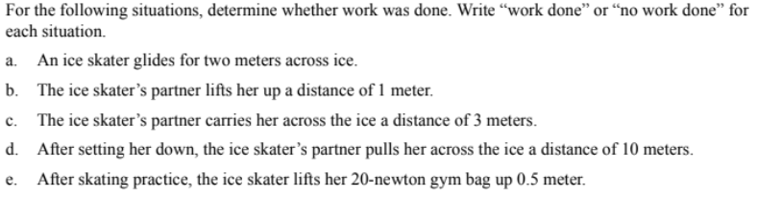

**Numericals:**

1. A book weighing 1.0 newton is lifted 2 meters. How much work was done?

1x2=2

2. A force of 15 newtons is used to push a box along the floor a distance of 3 meters. How much work was done?

15x3=45

3. It took 50 joules to push a chair 5 meters across the floor. With what force was the chair pushed?

50/5=10

4. A force of 100 newtons was necessary to lift a rock. A total of 150 joules of work was done. How far was the rock lifted?

5. It took 500 newtons of force to push a car 4 meters. How much work was done?

500nx4=2000

6. A young man exerted a force of 9,000 N on a stalled car but was unable to move it. How much work was done?

0

7. If 360 Joules of work is needed to move a crate a distance of 4 meters, what is the weight of the crate?

90

8. If a group of workers can apply a force of 1000 N to move a crate 20 meters, what amount of work will they have accomplished.

1,000x20=20,000

9. How much work is done in holding a 15 N sack of potatoes while waiting in line at the grocery store for 3 minutes?

15x3=45

10. A man exerts a force of 2kN on a boulder but fails to move it. Calculate the work done.

0

11. How much work would an 80 kg person have to do in order to lift his/her own body weight up the entire flight of stairs of the Empire State building (FYI: 1576 stairs!) , which is 320 meters high?

12. How much work does a football player do in the weight room when he squats 150 kg up a distance of 1 meter? How much work does he do if he does 3 sets of 10 squats in a row?

2000